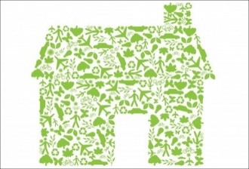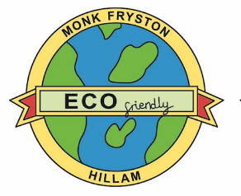

**Monk Fryston and Hillam**

**Sustainability Project**

*Update no 4*  *April 2021*

**What’s Happening?**

**Some Big Steps Forward**

**Solar Power Generation starts on March 5th 2021**

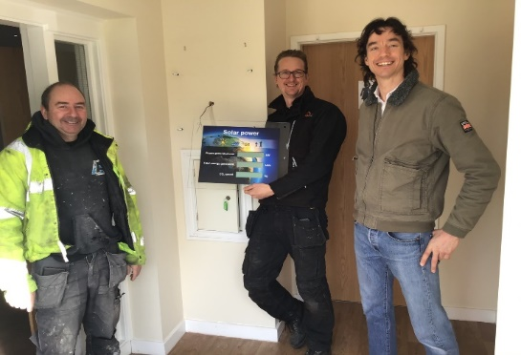 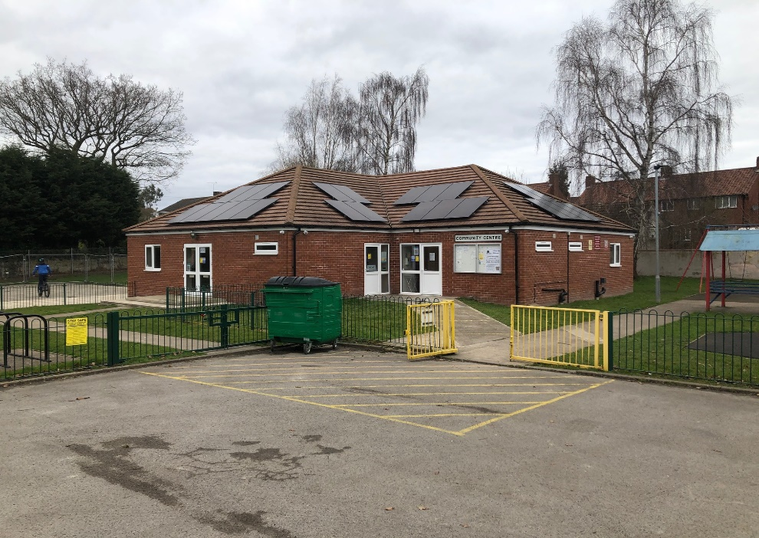

Our project and the Community Association took a big step forward on Friday 5th March when the 24 Solar PV panels were installed, started generating electricty and what’s more important were connected to the national grid.

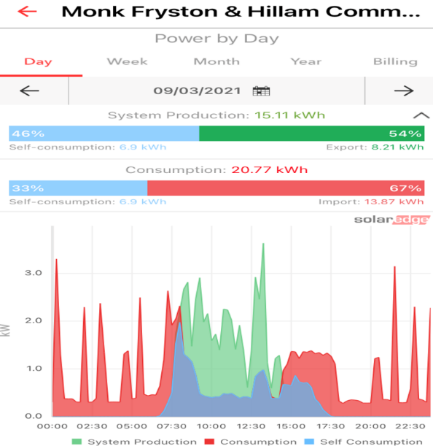During the rest of March over 550 kWh of electricity were generated being more than enough to offset the building’s own consumption albeit not always at the right time of day. A 10 kWh storage battery is still to be installed which will help balance the supply and demand. The main thing to do now is to sort out some mysterious power usage surges which have come to light via the real-time monitoring system. Since, this smart meter graph was down-loaded we have been assessing the cause of these regular spikes. What is clear is that we have a regular underlying 24 hour a day usage for Fire exit signs, CCTV security, wifi and fridges but the spikes are a mystery. However, better that we investigate than live in ignorance – so an investigation is underway. Who said smart meters were a waste of time!

We have installed a meter display in the entrance so everyone can see the impact we are making – in real-time.

**The WSP EcoWall Project**

Another grant, from Engineering Company WSP, funded the north wall insulation of the Community Centre main room, which was the Centre’s only remaining original wall.

Apart from the big benefit of improving the energy efficiency of the building and reducing the amount of gas being burnt to heat the Hall, we wanted to take before and after Thermal Images to illustrate the impact of insulation and demonstrate the value of having a Thermal Imaging survey on your own home. To say we had some surprises would be an understatement as you will see from these before pictures taken from both inside and outside the wall.

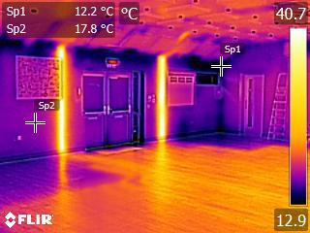On the left is a Thermal Imaging picture showing the EcoWall with the adjacent kitchen wall to the right. Two pipes feeding the underfloor heating (UFH) are clearly visible in the wall and the UFH under the floor covering.

The colour scale at the edge shows the temperature range and the two spots the actual temperatures. Note the dark blue ‘cold’ areas above the windows and emergency exit doors.

We also identified that two bulkheads at each end of the Hall were completely uninsulated.

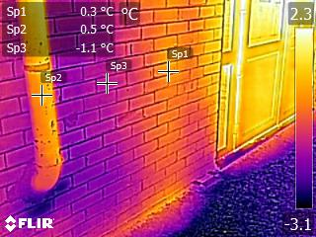The picture on the right is taken outside the north wall between the sheds and the Community Centre. When we first saw these pictures, we just couldn’t remember what the pipe was!

Later, we identified it as the soil vent pipe (SVP) from the Community Centre former gent’s toilet. It was much warmer than the surrounding brick wall and radiating heat to the outside. It appears that in our rush to redevelop the Community Centre in just 6 weeks in 2014 we must have blanked it off with plasterboard but didn’t remove or thermally insulate it. The underfloor heating pipe which showed up as a yellow column on the inside picture can be clearly seen as well as the low thermal performance of the exit doors glowing yellow.

We also took after pictures and made a complete thermal survey which really did show the benefit of the WSP funded insulation work. We will share this information with everyone in the Feasibility Study and Project Booklet we are now preparing and will distribute it to every household in Monk Fryston and Hillam.

The Thermal Camera is now being used by the other Project Partners to survey their buildings. Very shortly we will be launching the Community Thermal Imaging Campaign.

**The Locogen Feasibility Study**

After some delays due to covid restrictions, we received the final report in late March. It provides a detailed study and costed proposals for each of our Community Buildings. The proposals cover a wide range of renewable energy solutions so it provides a good range of system examples to review and assess if or when we come to consider how to heat our homes in the not-too-distant future.

A couple of things are apparent; one almost goes without saying but is worth stating nevertheless, *no two buildings are the same.* Each one varies in terms of the energy efficiency work needed to minimise the amount of energy required to power your daily living as well as the amount of money needing to be spent on energy (and potentially wasted). The second thing to note is that three of our community buildings require an electricity supply cable upgrade to install the proposed renewable energy solution.

Part of our project is to develop and capture our learning so we can share this with others and the solar panel power project at the Community Centre was the start of that process – understanding what we wanted to achieve and what compromises were necessary to develop the best solution.

**Hillam Parish Council investigation**

As reported last month, Hillam Council asked us to investigate the possibility of using a piece of their land on Betteras Hill for energy production. Locogen concluded that whilst it could be possible, at this stage it was not financially viable.

What Next? Five Major Steps

1. Now we have the final Feasibility Study each Partner organisation will have to decide how they want to proceed.
2. We will be sharing the full report with every resident via an online link.
3. We will be creating a small A5 booklet summarising the report and providing an update of the Project as it nears the end of its first year.

1. We will be looking for the funding for all the energy efficiency and renewable energy investments.
2. We will be setting up our on-line *Sustainability Information and Energy Advice Centre.* It will be available to everyone to share in our project learning. Currently, the intention is for this to be hosted on the Monk Fryston and Hillam Community Association website – look out for it – and watch it evolve at [www.mfhcc.com](http://www.mfhcc.com)

Thank you for your support.

The Steering Group and Project Partners