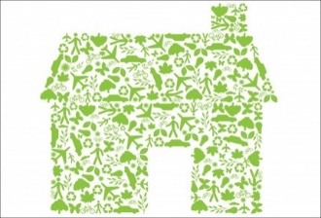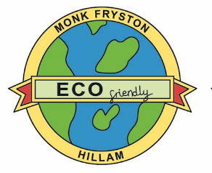

**Monk Fryston and Hillam**

**Sustainability Project**

*Update no 7* *October 2021*

**What’s Happening?**

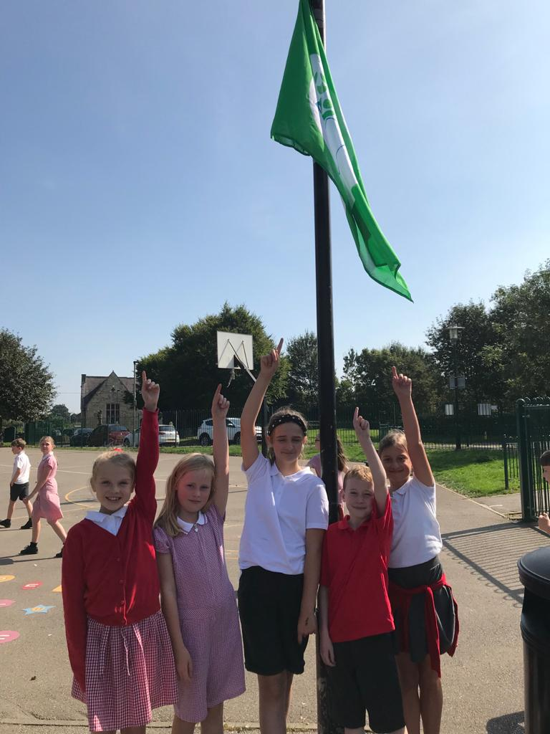**Tell COP26 - ‘We are trying to support you!’**

The delayed COP26 is just about to start. Let’s hope it is much more than a ‘talking shop’ and that substantial, practical policies and strategies are put in place to reduce carbon emissions. Over the past year or so, everyone must have noticed the growing public support to take action in some way or another.

Whilst we hear many criticisms of Government dithering, leading to confusion about what we, the members of the public should be doing, we know that the challenges they are facing are very complex and the technologies which may help reduce carbon emissions are still under development. They advocate pursuing a policy of ‘no regrets.’ This means doing things such as reducing your carbon emissions by improving your energy efficiency at home through better insulation, improving controls and replacing equipment such as lights and white goods with more efficient items when the time comes.

Meanwhile, evidence will be built up about the viability of renewable energy systems and we will be happy to share that information when you are ready to consider installing these systems.

**The Primary School attains Green Flag Status**

Pupils at Monk Fryston CE Primary School were delighted to be awarded the Eco Schools Green Flag Award in recognition for their hard work in environmental education.

The school formed a committee of Eco Warriors who led a number of actions that benefited their school and community. During lockdown, children were set a number of eco challenges to improve their understanding of environmental themes. This work gained Highly Commended in the Better Energy School Awards.

In school, the Eco Warriors completed an audit of their environmental standards for the Green Flag Award and identified aspects of energy, waste and transport that they particularly wanted to improve. Their actions included using a heat camera to identify areas of the building that would benefit from energy efficiency measures; increasing the amount of waste that could be composted or recycled; and holding a cycle to school challenge to reduce the number of pupils arriving by car.

Headteacher, Mr Rick Weights, said “We are incredibly proud of what our Eco Warriors have achieved. Environmental education is an extremely important aspect of our curriculum. As a school, we have a duty to inform and empower the next generation of global citizens, and this award recognises the successful ways that we have been working to achieve this aim.” The Green Flag now flies proudly in the school playground.

**What next at the school**?

The award lasts for 2 years, when the school can re-apply for accreditation. Currently, the judgement criteria are being reviewed so the school doesn’t yet know what they have to achieve to maintain their status but they haven’t sat back on their laurels.

The pupils have decided that this year, whilst continuing to maintain their environmental good practices they are going to focus on biodiversity. Plans are underway and will be shared in the next update. Meanwhile, the school has joined the **Let’s Go Zero Coalition**.

 Let’s Go Zero is led by a strong coalition of organisations: WWF, the Carbon Trust, Global Action Plan, Sustrans, Fairtrade, Ashden, EcoSchools and the Soil Association. The campaign is actively supported by over 30 Local Authorities across the UK, the Church of England, the National Education Union and the UK High Level Climate Champions Team among others. Nearly 500 schools and colleges have signed up from Plymouth to Inverness with more joining every day, representing over 219,312 students and 31,646 teachers.  Including the 205 children and 28 staff in my school.

The Let’s Go Zero vision for 2030.

* All young people receive a robust climate education and leave school ready to engage in zero carbon jobs and lifestyles.
* The UK school estate will have been retrofitted - leading to the growth of local green skills and jobs and it will have been adapted to the changing climate to improve its resilience to extreme weather.
* All new school buildings built will be net zero carbon from 2022.

**And finally… last but by no means least**…. During the summer some of the school’s original draughty windows were replaced as part of their energy efficiency plan and recently an application has been made to SALIX to fund ground source heat pumps and solar panels.

Our congratulations to Rick and all the school members on their collective achievements; we wish them well with their new projects – and of course we have our fingers crossed with their SALIX loan application.

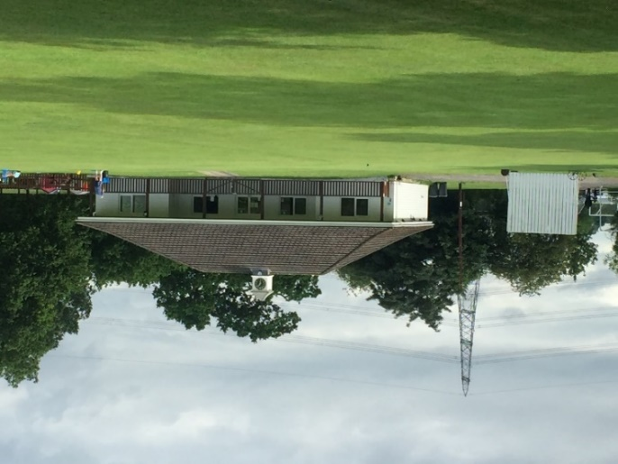**News from the other Project Partners**

All the partners: St Wilfrid’s, the Football Club, the Cricket Club and the Community Association are busy trying to support the objectives of COP26 and reduce carbon emissions in one way or another. All the partners have met with prospective renewable energy contractors and had their premises surveyed; this is essential preparation for submitting grant applications to fund the necessary renewable energy systems – heat pumps, solar panels and energy storage batteries.

**The Football Club** is trying to raise funds to install a solar powered (with battery) floodlight system to allow teams to train at Stocking Lane during the dark nights. Currently, they train indoors which means all the players travel out of the village to train – imagine the Co2 savings and environmental benefits – 170 players every week – that’s also a lot of fuel saved. We’ll keep you posted on progress.

**The Cricket Club** is putting together a detailed plan to replace the Cess Pit, which serves all the users of the Pavilion (including the Football Club) with either a mains sewer connection or a biodigester. They hope to be in a position to formally launch the project in the New Year. The intention is that renewable energy systems will then follow in due course.

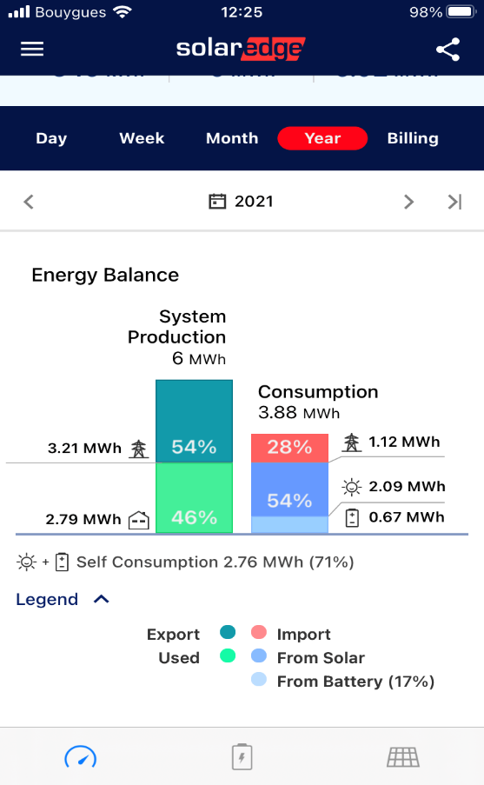**St Wilfrid’s Church** is focussing on the Church Hall. Surveys by the renewable energy suppliers led to concerns about the fabric of the Hall which was built in 1970. Further investigation has revealed that the original building has no insulation in the roof and walls, and that it needs a ‘make over’. The preparation work for a major restoration project including installing an air source heat pump to replace an old gas boiler is underway with the aim of applying for grants either in November or February 2022.

**The Community Association** has been in discussion with the Lottery Fund for a few months about a grant from their *Reaching Communities Fund*. This is for a 2year Community Project designed to actively share Carbon Reduction and Renewable Energy Information with residents and others who are interested. As part of this project, they would fund an air source heat pump and further energy efficiency work at the Community Centre. We are pleased to report that we passed their first stage assessment and have now submitted a formal application with the aim of starting early next year. Another deep breath as we await news from the Lottery.

Also, we are pleased to report that the solar panel installation has performed well over the past 6 months and provided excellent data plus reduced our demand on the grid and has currently generated 6 MW hours of electricity, thus saving the Co2 equivalent of planting 70 trees. We have consumed just under 50% of our production and exported the rest but we expect to use much more if we install an air source heat pump.

**Finally, Covid permitting, we would love to meet you** and will host an information day in the Community Centre Conservatory when the National Grid hold their Yorkshire Green Consultation for the proposed expansion of the Rawfield Lane sub-station in the Main Hall. It is a major infrastructure project linked to the massive increase in electricity generated in the North Sea, in Scotland and further afield and it will be imported via interconnectors from the continent into our national network.

**It is on Saturday November 13th between 10.30 and 5pm**

We will display more of what has been achieved by the Partners in the past 18 months – we look forward to seeing you and invite you and your friends to come too.

**Into 2022…**

We hope to be reporting back on some more solid progress and subject to lottery funding hold a series of events showcasing what has been achieved to date in our two villages. We plan to host a series of expert speakers on a range of sustainability topics.

**Please remember**

1. The Community Centre website now has a section dedicated to the project, our embryonic *Sustainability Information and Energy Advice Centre* – where you can find the full Interim and Final Feasibility study reports [www.mfhcc.com/sustainability-project/news-about-us/](http://www.mfhcc.com/sustainability-project/news-about-us/)
2. We hope you found the Project Booklet which we distributed in July 2021 of interest. If anyone did not receive a copy and would like one, please contact us as shown below.
3. If you have any feedback or comments to share or require further information please contact me: Ray Newton on 01977 682084 or 07706 795334 or via [www.mfhcc.com/sustainability-project/news-about-us/contact-us/](http://www.mfhcc.com/sustainability-project/news-about-us/contact-us/)

Thank you for your support.

The Steering Group and Project Partners