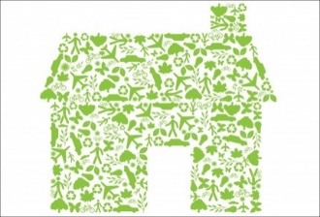
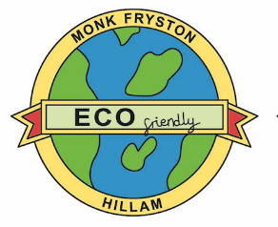
Monk Fryston and Hillam Sustainability Project

What’s Happening?
Well – despite the project getting off to a great start last year, I don’t think anyone was sad to see the back of 2020. The New Year is here and we wish everyone all the best for 2021. We have lots happening on the project and want to let you know about the progress … so let’s get started.
First of all, I hope you notice our two logos; the original Green House logo has featured on our regular Project updates (please contact susi_newton28@hotmail.com to be put on the mailing list for project updates). It has been joined by a new friend designed by a Monk Fryston Primary School pupil. This was chosen with much difficulty from a shortlist of inspired designs made during their recent Environmental Green Flag work. Other shortlisted designs can be seen elsewhere in this edition. The Steering Group were so impressed by all the designs they decided to award a badge to each pupil to recognise their learning to improve the world they live in. A very big ‘Well Done’ to Pupils and Staff of the school.
Secondly, we were delighted to report in the last edition of Hillam News that we had been awarded a grant to conduct a Feasibility Study to determine if our aim of making all Community Buildings Carbon Neutral by 2022 was possible. We are pleased to report that our consultants Locogen started work in early October with a desk top study. Their 48page report was presented later that month to the Project Partners who wholeheartedly agreed that they should proceed to the second more detailed phase of the study involving site visits. Unfortunately, the second Covid lockdown threatened to delay the project, so the partners with the help of Locogen supplied all the necessary information themselves. The study will conclude in late January and the report will be shared with residents shortly afterwards.
As you will see elsewhere in this edition of Hillam News, we are absolutely delighted that one of our aspirations will be fulfilled early in the New Year as we have secured a grant from the Post Code Lottery to obtain a Thermal Imaging Camera. Our intention is to use this camera to survey our Community Buildings and identify where they are losing heat. It is part of each Partner’s energy efficiency project to reduce their energy consumption. The next step is to offer residents and other local building owners the chance to have a thermal image survey so they too can take remedial action. You can read more elsewhere about how to take advantage of this offer.
The Post Code Lottery award will also provide our first renewable energy scheme; Solar PV Panels and Batteries for the Community Centre. These will tie in with the Locogen Feasibility Study recommendations and we are really pleased to be on our way to achieving some of our aims and hope to have them installed by late spring.
We were also pleased when a resident told us that his Company were running a competition to award a £2,500 grant which he thought might complement our project. A week or so of mulling over ideas resulted in a bid to insulate one of the original uninsulated walls at the Community Centre which could be used as a Before and After case study for the Community Thermal Imaging Campaign. We have yet to hear the result of the bid – so it’s fingers crossed time!
Notwithstanding the outcome of this particular grant application, if anyone works for an organisation that offers grants to communities or knows of any other source of a grant please get in touch. We will be delighted to follow up and investigate the opportunity.
Thank you for your support.
The Steering Group and Project Partners
Stop Press: We received Wonderful News from Ben Thompson, on behalf of the engineering group WSP UK, early in the New Year when he told us that we had won the £2,500 grant to create the ‘WSP Eco Wall’ at the Community Centre. Look out for more information in the next edition of the News.

